Chapter 19, Solution 85

(a) Since A = and C = , we let V₁ = 1 V and open-circuit the output port. The schematic is shown below. In the AC Sweep box, we set Total Pts = 1, Start Freq = 0.1592, and End Freq = 0.1592. After simulation, we obtain an output file which includes

FREQ IM(V_PRINT1) IP(V_PRINT1)
1.592 E–01 6.325 E–01 1.843 E+01

FREQ VM($N_0002) VP($N_0002)
1.592 E–01 6.325 E–01 –7.159 E+01

From this, we obtain

A =

C = = j

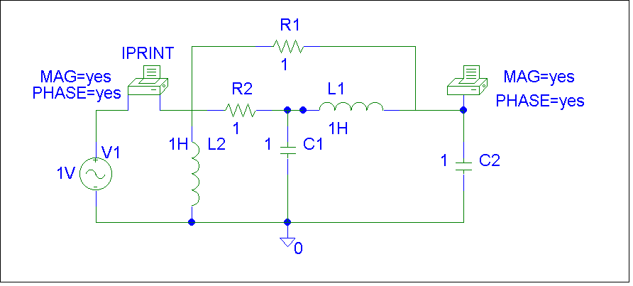

(b) Similarly, since B = and D = , we let V₁ = 1 V and short-circuit the output port. The schematic is shown below. Again, we set Total Pts = 1, Start Freq = 0.1592, and End Freq = 0.1592 in the AC Sweep box. After simulation, we get an output file which includes the following results:

FREQ IM(V_PRINT1) IP(V_PRINT1)
1.592 E–01 5.661 E–04 8.997 E+01

FREQ IM(V_PRINT3) IP(V_PRINT3)
1.592 E–01 9.997 E–01 –9.003 E+01

From this,

B =

D = = 5.561x10^{–4}

=

